**IST 659 Lab Assignment 5**

**SQL Statements:**

/*Creating States table*/

CREATE TABLE STATES_table

(

stateAbbr VARCHAR(2) PRIMARY KEY ,

stateName VARCHAR(20) NOT NULL ,a

);

/*Creating CITY table*/

CREATE TABLE CITY_table

(

cityID CHAR(8) PRIMARY KEY ,

cityName VARCHAR(25) NOT NULL ,

stateAbbr VARCHAR(2) FOREIGN KEY(stateAbbr) REFERENCES STATES_table(stateAbbr) NOT NULL,

);

/*Creating AIRPORT table*/

CREATE TABLE AIRPORT_table

(

airportID CHAR(3) PRIMARY KEY ,

airportName VARCHAR(45) UNIQUE NOT NULL ,

cityID CHAR(8) FOREIGN KEY(cityID) REFERENCES CITY_table(cityID) NOT NULL,

);

SELECT * FROM AIRPORT_table

/*Creating FLIGHTROUTE table*/

CREATE TABLE FLIGHTROUTE_table

(

flightNumber VARCHAR(6) PRIMARY KEY ,

departAirport CHAR(3) FOREIGN KEY(departAirport)REFERENCES AIRPORT_table(airportID),

arriveAirport CHAR(3) FOREIGN KEY(arriveAirport)REFERENCES AIRPORT_table(airportID),

scheduledDepartTime TIME NOT NULL,

scheduledArrivalTime TIME NOT NULL,

);

/*Creating FLIGHTSTATUS table*/

CREATE TABLE FLIGHTSTATUS_table

(

statusID CHAR(1) PRIMARY KEY NOT NULL,

CONSTRAINT chk3_statusID CHECK (statusID='O'OR statusID='C' OR statusID='D'),

description VARCHAR(20) NOT NULL,

);

/*Creating AIRCRAFTSPECS table*/

CREATE TABLE AIRCRAFTSPECS_table

(

aircraftTypeID CHAR(8) PRIMARY KEY NOT NULL,

aircraftVersion VARCHAR(10) NOT NULL,

cabinNumOfSeats INT,

fuelCapacity INT NOT NULL,

);

/*Creating AIRPLANE table*/

CREATE TABLE AIRPLANE_table

(

airplaneID CHAR(8) PRIMARY KEY NOT NULL,

aircraftTypeID CHAR(8) FOREIGN KEY(aircraftTypeID) REFERENCES AIRCRAFTSPECS_table(aircraftTypeID) NOT NULL,

purchaseDate DATETIME Default '01/02/2014' NOT NULL,

);

/*Creating FLIGHTSCHEDULE table*/

CREATE TABLE FLIGHTSCHEDULE_table

(

flightNumber VARCHAR(6) NOT NULL,

CONSTRAINT FK1_FlightNumber foreign key (flightNumber)REFERENCES FLIGHTROUTE_table(flightNumber),

flightDate DATE,

CONSTRAINT PK1_xyz PRIMARY KEY (flightDate,flightNumber),

statusID CHAR(1) FOREIGN KEY(statusID) REFERENCES FLIGHTSTATUS_table(statusID) NOT NULL,

CONSTRAINT ck1_statusID CHECK (statusID='O'OR statusID='C' OR statusID='D'),

airplaneID CHAR(8) FOREIGN KEY(airplaneID)REFERENCES AIRPLANE_table(airplaneID) NOT NULL,

delayDepartTime TIME ,

delayArrivalTime TIME,

);

/*Inserting Values into STATES table*/

INSERT INTO STATES_table

VALUES

('CA','California'),

('DC','Washington.D.C.'),

('FL','Florida'),

('IL','Illinois'),

('MA','Massachusetts'),

('NY','New York'),

('TX','Texas')

/*Select all the columns

of all the records

in the STATES table:*/

SELECT * FROM STATES_table

/*Inserting Values into CITY table*/

INSERT INTO CITY_table

VALUES

('C001','Los Angeles','CA'),

('C002','San Francisco','CA'),

('C003','Washington.D.C.','DC'),

('C004','Miami','FL'),

('C005','Orlando','FL'),

('C006','Chicago','IL'),

('C007','Boston','MA'),

('C008','New York','NY'),

('C009','Syracuse','NY')

/*Select all the columns

of all the records

in the CITY table:*/

SELECT * FROM CITY_table

/*Inserting Values into AIRPORT table*/

INSERT INTO AIRPORT_table

VALUES

('BOS','Rathod','C007'),

('DCA','Ronald Reagan National Airport','C003'),

('IAD','Washington Dulles International Airport','C003'),

('JFK','John F. Kennedy International Airport','C008'),

('LAX','Los Angeles International AIrport','C001'),

('LGA','LaGuardia Airport','C008'),

('MCO','Orlando International Airport','C005'),

('MDW','Chicago Midway International Airport','C006'),

('MIA','Miami International Airport','C004'),

('ORD','Chicago O Hare International Airport','C006'),

('SFO','San Francisco International Airport','C002'),

('SYR','Syracuse Hancook International Airport','C009')

/*Select all the columns

of all the records

in the AIRPORT table:*/

SELECT * FROM AIRPORT_table

/*Inserting Values into FLIGHTROUTE table*/

INSERT INTO FLIGHTROUTE_table

VALUES

(3310,'SYR','JFK','08:00:00.0000000','09:02:00.0000000'),

(3312,'JFK','SYR','12:20:00.0000000','13:30:00.0000000'),

(3426,'LAX','ORD','11:15:00.0000000','15:05:00.0000000'),

(5063,'BOS','MCO','14:30:00.0000000','18:45:00.0000000')

/*Select all the columns

of all the records

in the FLIGHTROUTE table:*/

SELECT * FROM FLIGHTROUTE_table

/*Inserting Values into FLIGHTSTATUS table*/

INSERT INTO FLIGHTSTATUS_table

VALUES

('C','Cancelled'),

('D','Delayed'),

('O','On Time')

/*Select all the columns

of all the records

in the FLIGHTSTATUS table:*/

SELECT * FROM FLIGHTSTATUS_table

/*Inserting Values into AICRAFTSPECS table*/

INSERT INTO AIRCRAFTSPECS_table

VALUES

('AIR1','A321-200',220,7930),

('AIR2','737-600ER',132,6875),

('BOE1','747-400ER',416,63705),

('BOE2','767-300ER',350,23980),

('BOE3','737-600ER',132,6875)

/*Select all the columns

of all the records

in the AIRCRAFTSPECS table:*/

SELECT * FROM AIRCRAFTSPECS_table

/*Inserting Values into AIRPLANE table*/

INSERT INTO AIRPLANE_table

VALUES

('AP098640','AIR2','2013-03-01'),

('AP239471','AIR1','1900-01-01'),

('AP309814','BOE2','2012-05-22'),

('AP629342','BOE1','1900-01-01'),

('AP872139','BOE3','1900-01-01'),

('AP998911','BOE2','1900-01-01')

/*Select all the columns

of all the records

in the AIRPLANE table:*/

SELECT * FROM AIRPLANE_table

/*Inserting Values into FLIGHTSCHEDULE table*/

INSERT INTO FLIGHTSCHEDULE_table

VALUES

(3310,'2014-02-10','O','AP629342','',''),

(3310,'2014-02-11','O','AP629342','',''),

(3312,'2014-02-10','O','AP872139','',''),

(3426,'2014-02-12','O','AP239471','',''),

(5063,'2014-02-13','D','AP309814','15:40:00.0000000','20:05:00.0000000')

/*Select all the columns

of all the records

in the FLIGHTSCHEDULE table:*/

SELECT * FROM FLIGHTSCHEDULE_table

**SQL STATEMENTS AND OUTPUS SCREENSHOTS:**

**STATE table:**

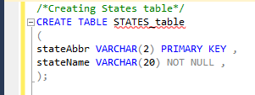

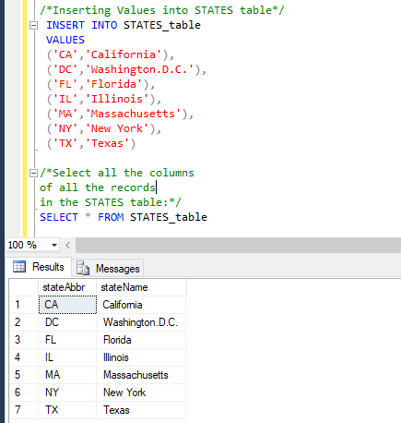

**CITY table:**

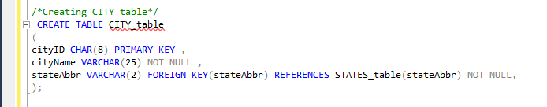

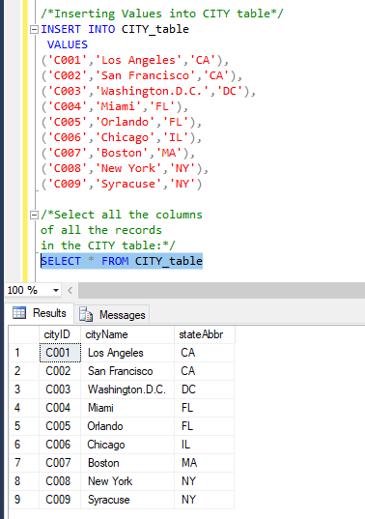

**AIRPORT table:**

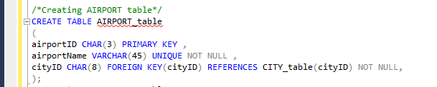

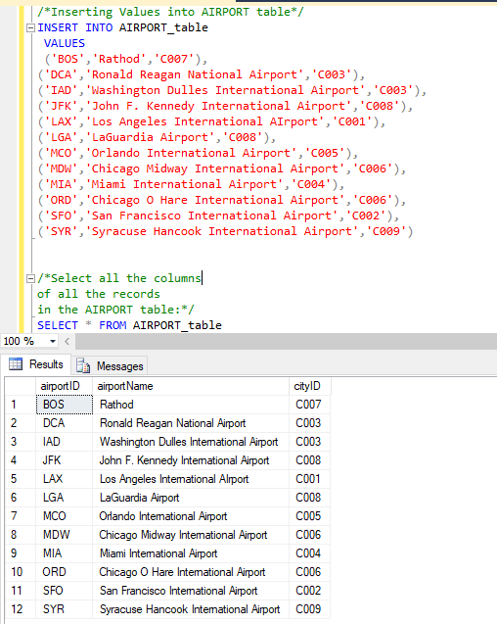

**FLIGHT ROUTE table:**

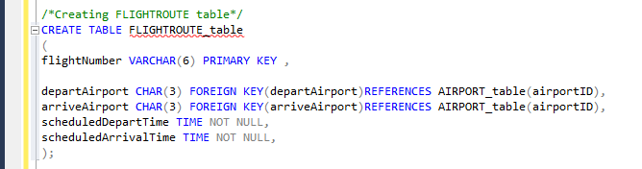

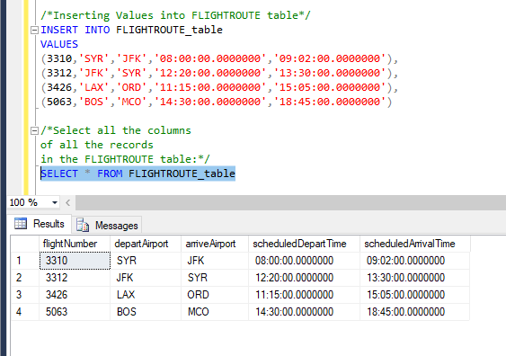

**FLIGHT STATUS table:**

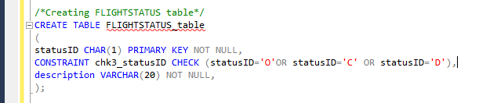

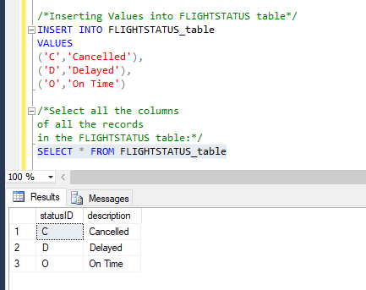

**AIRCRAFTE SPECS table:**

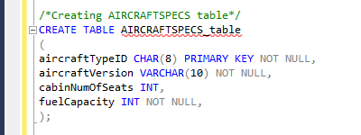

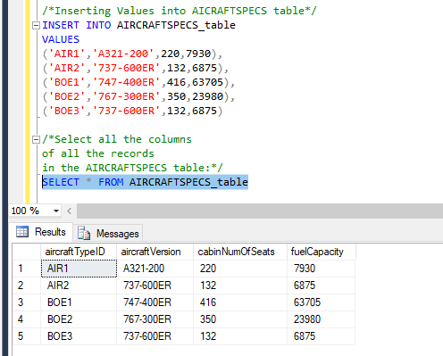

**AIRPLANE table:**

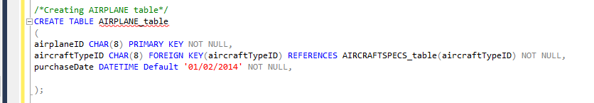

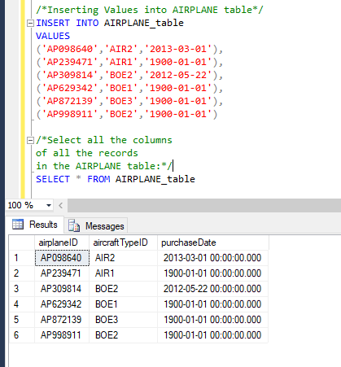

**FLIGHT SCHEDULE table:**

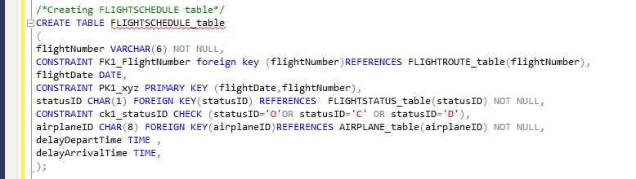

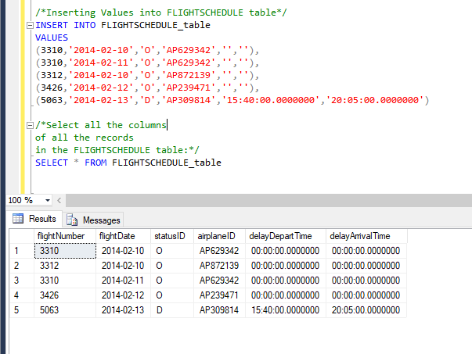

**Queries:**

1. Find all aircrafts whose fuel capacity is less than 63705. Show aircraft id, cabin number of seats and fuel capacity.

/*aircrafts whose fuel capacity is less than 63705 form AIRCRAFTSPECS TABLE*/

SELECT aircraftTypeID, cabinNumOfSeats,fuelCapacity FROM AIRCRAFTSPECS_table

WHERE fuelCapacity < 63705;

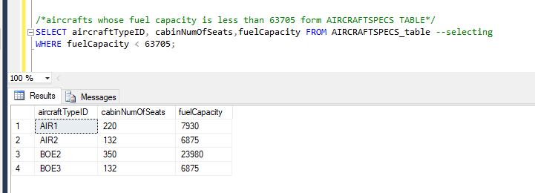

1. Find all airplanes which were on time or delayed. Show only airplane ID, flight date and statusID.

/*all airplanes which were on time or delayed from FLIGHTSCHEDULE table*/

SELECT airplaneID, flightDate, statusID from FLIGHTSCHEDULE_table

WHERE statusID='O' or statusID='D';

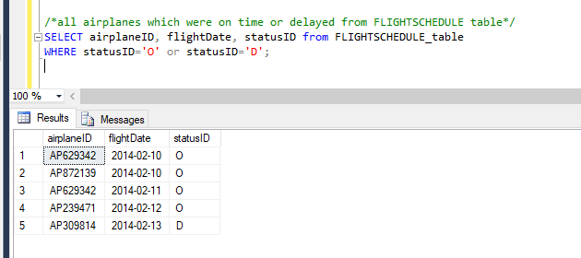

1. Find all the airplanes that have been purchased before the year 2013-02-10. Show airplane id and the purchase Date.

/*all the airplanes that have been purchased before the year 2013-02-10 from AIRPLANE table*/

SELECT airplaneID, purchaseDate from AIRPLANE_table

WHERE purchaseDate<'2013-02-10';

